**Graph**

A Graph is a non-linear data structure consisting of nodes and edges. The nodes are sometimes also referred to as vertices and the edges are lines or arcs that connect any two nodes in the graph. More formally a Graph can be defined as,

*A Graph consists of a finite set of vertices(or nodes) and set of Edges which connect a pair of nodes.*

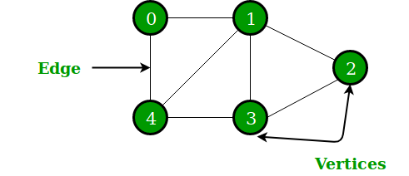



In the above Graph, the set of vertices V = {0,1,2,3,4} and the set of edges E = {01, 12, 23, 34, 04, 14, 13}.

Graphs are used to solve many real-life problems. Graphs are used to represent networks. The networks may include paths in a city or telephone network or circuit network. Graphs are also used in social networks like linkedIn, Facebook. For example, in Facebook, each person is represented with a vertex(or node). Each node is a structure and contains information like person id, name, gender, locale etc.

A graph can be directed or undirected. However, in an undirected graph, edges are not associated with the directions with them. An undirected graph is shown in the above figure since its edges are not attached with any of the directions. If an edge exists between vertex A and B then the vertices can be traversed from B to A as well as A to B.

In a directed graph, edges form an ordered pair. Edges represent a specific path from some vertex A to another vertex B. Node A is called initial node while node B is called terminal node.

A directed graph is shown in the following figure.

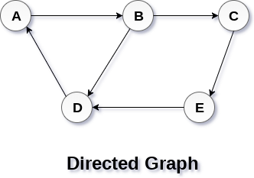

Graph Terminology

Path

A path can be defined as the sequence of nodes that are followed in order to reach some terminal node V from the initial node U.

Closed Path

A path will be called as closed path if the initial node is same as terminal node. A path will be closed path if V0=VN.

Simple Path

If all the nodes of the graph are distinct with an exception V0=VN, then such path P is called as closed simple path.

Cycle

A cycle can be defined as the path which has no repeated edges or vertices except the first and last vertices.

Connected Graph

A connected graph is the one in which some path exists between every two vertices (u, v) in V. There are no isolated nodes in connected graph.

Complete Graph

A complete graph is the one in which every node is connected with all other nodes. A complete graph contain n(n-1)/2 edges where n is the number of nodes in the graph.

Weighted Graph

In a weighted graph, each edge is assigned with some data such as length or weight. The weight of an edge e can be given as w(e) which must be a positive (+) value indicating the cost of traversing the edge.

Digraph

A digraph is a directed graph in which each edge of the graph is associated with some direction and the traversing can be done only in the specified direction.

Loop

An edge that is associated with the similar end points can be called as Loop.

Adjacent Nodes

If two nodes u and v are connected via an edge e, then the nodes u and v are called as neighbours or adjacent nodes.

Degree of the Node

A degree of a node is the number of edges that are connected with that node. A node with degree 0 is called as isolated node.

# **Graph Representation**

By Graph representation, we simply mean the technique which is to be used in order to store some graph into the computer's memory.

There are two ways to store Graph into the computer's memory. In this part of this tutorial, we discuss each one of them in detail.

## 1. Sequential Representation

In sequential representation, we use adjacency matrix to store the mapping represented by vertices and edges. In adjacency matrix, the rows and columns are represented by the graph vertices. A graph having n vertices, will have a dimension **n x n**.

An entry Mij in the adjacency matrix representation of an undirected graph G will be 1 if there exists an edge between Vi and Vj.

An undirected graph and its adjacency matrix representation is shown in the following figure.

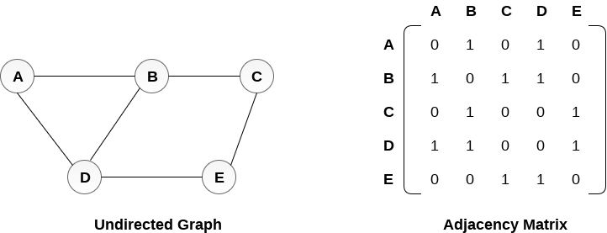

in the above figure, we can see the mapping among the vertices (A, B, C, D, E) is represented by using the adjacency matrix which is also shown in the figure.

There exists different adjacency matrices for the directed and undirected graph. In directed graph, an entry Aij will be 1 only when there is an edge directed from Vi to Vj.

A directed graph and its adjacency matrix representation is shown in the following figure.

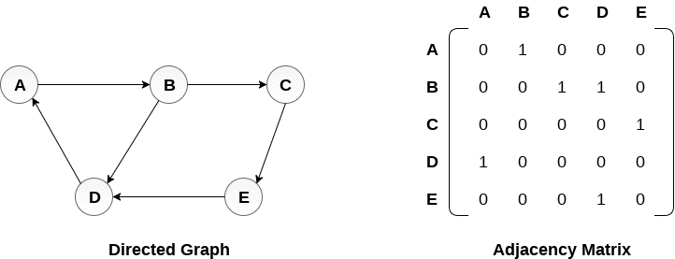

Representation of weighted directed graph is different. Instead of filling the entry by 1, the Non- zero entries of the adjacency matrix are represented by the weight of respective edges.

Representation of weighted directed graph is different. Instead of filling the entry by 1, the Non- zero entries of the adjacency matrix are represented by the weight of respective edges.

The weighted directed graph along with the adjacency matrix representation is shown in the following figure.

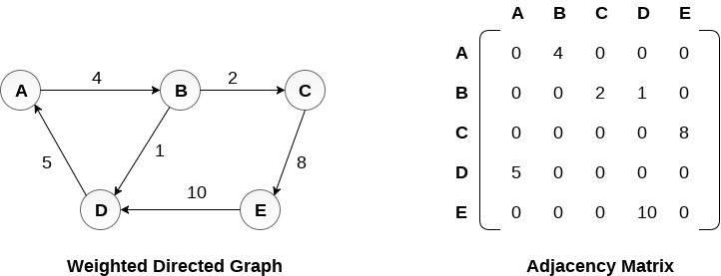

## Linked Representation

In the linked representation, an adjacency list is used to store the Graph into the computer's memory.

Consider the undirected graph shown in the following figure and check the adjacency list representation.

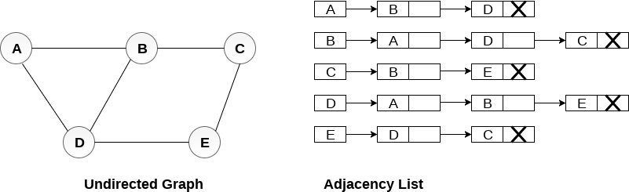

An adjacency list is maintained for each node present in the graph which stores the node value and a pointer to the next adjacent node to the respective node. If all the adjacent nodes are traversed then store the NULL in the pointer field of last node of the list. The sum of the lengths of adjacency lists is equal to the twice of the number of edges present in an undirected graph.

Consider the directed graph shown in the following figure and check the adjacency list representation of the graph.

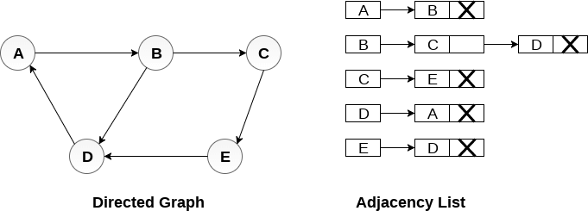

In a directed graph, the sum of lengths of all the adjacency lists is equal to the number of edges present in the graph.

In the case of weighted directed graph, each node contains an extra field that is called the weight of the node. The adjacency list representation of a directed graph is shown in the following figure.

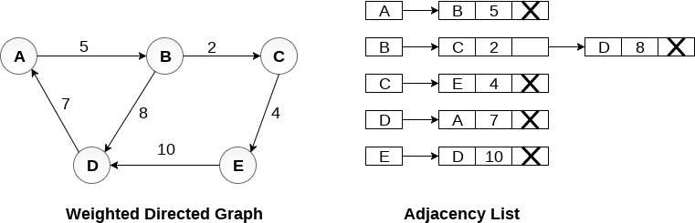

Example

Graph and its representations - GeeksforGeeks

0 1 2 3 4

0

1

2

3

4